
School:.............................................................................................................Campus:....................................................... AcademicYear:......................SubjectName:...........................................................SubjectCode:..........................
Semester:...............Program:........................................Branch:.........................Specialization:.......................... Date: .....................................
(Learning by Doing and Discovery)
ERC-20 Basics
* Coding Phase: Pseudo Code / Flow Chart / Algorithm
Algorithm Steps:
- Develop a new ERC-20 token smart contract using Remix IDE.
- Set up essential parameters including the token’s name, symbol, total supply, and number of decimals.
- Code the standard ERC-20 functions such as balanceOf, transfer, approve, and transferFrom.
- Compile and deploy the token contract to a test network through MetaMask.
- Confirm and interact with your token using a blockchain explorer or compatible
crypto wallet.

* Softwares used


- RemixIDE
- MetaMask
- Etherscan
- OpenZeppelinContracts
- BraveWebBrowser


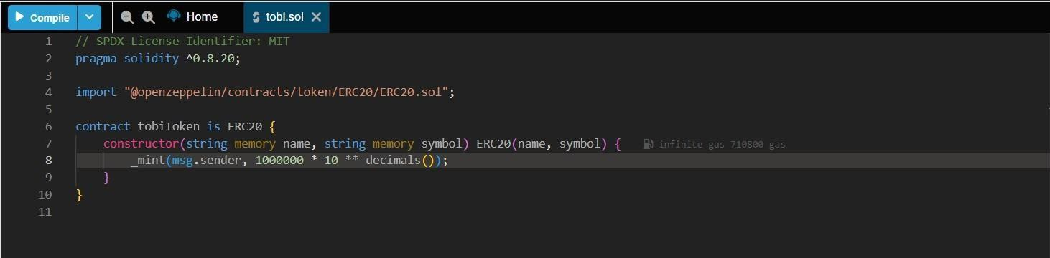
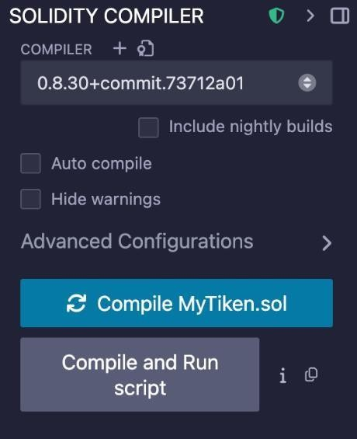
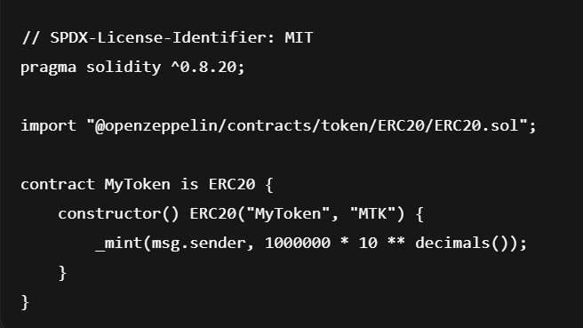

• Go to https://remix.ethereum.org using your web browser.
• Inside the “contracts” folder, click the “+” (new file) button and create a file named MyToken.sol.
• Insert the ERC-20 token Solidity code, making use of the OpenZeppelin library for standard
implementation.

- Go to the Solidity Compiler tab, select version 0.8.20, and click Compile MyToken.sol.

- Ensure there are no compilation errors before proceeding.

Deployment Phase
• In Remix, open the “Deploy & Run Transactions” panel.
• From the Environment menu, choose Injected Provider – MetaMask, and allow Remix to connect with your MetaMask wallet.
• Click Deploy, then confirm the transaction when prompted by MetaMask. Wait until the network confirms the deployment.
• After successful deployment, copy the contract address displayed in Remix or in your MetaMask activity.
• Go to https://sepolia.etherscan.io and paste your contract address into the search bar to view the token’s information on the Sepolia testnet.

Add Token to MetaMask

- Open MetaMask and select the Import Tokens option.
- Paste your contract address into the address field.
- MetaMask should automatically populate the token symbol and decimal places.
- Click Add Custom Token, then select Import Tokens to finalize.
- Your wallet will now display your token balance (for example, 1,000,000 MTK).

Transfer Tokens to Another Wallet
• Go back to Remix and locate your contract under the Deployed Contracts section.
• Expand it and find the transfer (address, uint256) function.
• Input the recipient’s wallet address and the amount of tokens to send.
• Confirm the transaction in MetaMask when prompted.
• To verify, open Etherscan (Sepolia Testnet) and search using the transaction hash to view the details of your token transfer.


* Implementation Phase: Final Output (no error) Applied and Action Learning
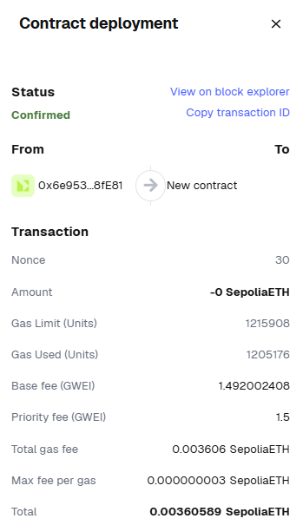
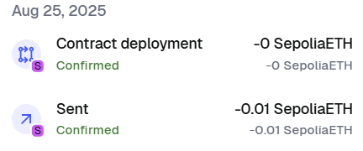
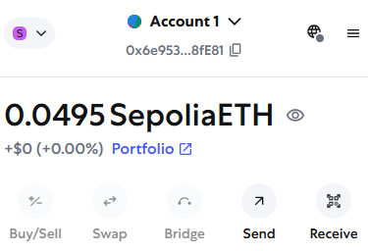

* Observations

- The ERC-20 token contract compiled without any syntax or logic errors.
- Deployment was completed using MetaMask with smooth testnet integration.
- Token appeared automatically in MetaMask after import.
- Transaction verified on Etherscan showed accurate transfer data.
- The OpenZeppelin library simplified token creation and ensured ERC-20 compliance.

Rubrics
Concept | 10
Planning and Execution/  Practical Simulation/ Programming | 10
Result and Interpretation | 10
Record of Applied and Action Learning | 10
Viva | 10
Total | 50


Signature of the Student:
Signature of the Faculty:

